****Vision for Learning:

*‘To develop aspirant, resilient learners who are empowered global citizen*s’

2020

*“We are committed to keeping children safe from harm and have a zero tolerance of child abuse”*

*“We support and promote Respectful Relationships”*

**Enrolment, Transition & General Information**



Reserve Street, Eaglehawk, 3556

Postal Address: PO Box 146, Eaglehawk 3556

Telephone (03) 5446 8099

Facsimile (03) 5446 1376

[**www.eaglehawksc.vic.edu.au**](http://www.eaglehawksc.vic.edu.au)

_____________________________________________

# **Term Dates - 2020**

Term 1 Tue 28th January (Teachers Commence)

Wed 29th January – Ready to Learn Parent/Student Interviews 2pm – 7pm

Thurs 30th January – Ready to Learn Parent/Student Interviews 9am – 4pm

Fri 31st January – Formal Classes Commence

Fri 27th March – end of Term 1

Term 2 14th April to 26th June  
Term 3 13th July to 18th September  
Term 4 5th October to 18th December

# **Values**

Eaglehawk Secondary College aims to provide a caring environment that connects with students’ interests to support their learning so that they can achieve their best.

The College is committed to developing in students an appreciation of life-long learning. It has a strong focus on respect for yourself, the school and others around you, while encouraging confidence, courage, persistence and teamwork.

Eaglehawk Secondary College values COMMUNITY, provides OPPORTUNITIES, builds RELATIONSHIPS and has high EXPECTATIONS of EFFORT AND ACHIEVEMENT. These are our CORE values.

The College is committed to communicating our school-wide practices, including Policies and Procedures and the Annual Report to our school community. Methods of communication include the college newsletter, college website, Facebook page, COMPASS. Presentations of the Annual Report occur at the Annual General Meeting and subsequent parent-teacher conferences.

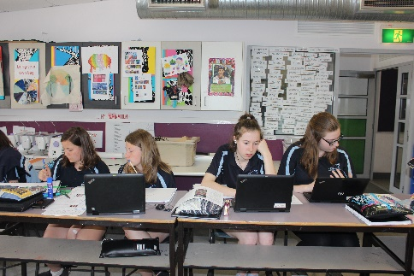

# **Features of Eaglehawk Secondary College**

Eaglehawk Secondary College is a Year 7 to 10 School that prepares students for Year 11 & 12, further study or the workforce. The College has a student population of approximately 650 students who live in Eaglehawk, Bendigo and adjacent rural communities.

In 2008 building commenced at Eaglehawk Secondary College on a new school. Construction is now complete and provides a fantastic, flexible and comfortable learning environment for students and staff.

Features of the College are:

* A well-balanced curriculum organised around the Victorian Curriculum.
* Learning that is relevant and caters to student interests in:
  + Applied and practical learning.
  + A commitment to the development of students’ social skills and Respectful Relationships through our teacher advisor program.
  + Literacy and Numeracy programs that cater for individual needs.
  + An excellent reputation for special programs.
  + Programs that reflect a sense of community and draw on the support of community initiatives.
  + Indoor/outdoor connections for learning.
  + VCE and VET options for Year 10 students who wish to extend their learning.
  + Eaglehawk Secondary College Sports Development Program
* Each student is supported by two Teacher Advisors who provide assistance in regard to well-being, mentoring and academic support.
* A highly qualified and committed staff with a depth of experience and broad range of expertise.

**Learning Communities**Learning Communities accommodate approximately 150 students. The Community setting caters for core curriculum classes and provides the base for their management and welfare as students, individuals and a group.

Small teams of teachers provide home group support to small groups of students in each neighbourhood, this helps develop a culture of high expectations under pinned by a commitment to effort and hard work by all.

The flexible learning spaces and network cabling support the extensive use of Information Communication Technologies. The design of the Communities allows effective supervision of all students and includes social spaces where personal relationships are formed.

Learning Communities also include studio classrooms for up to 25 students; interview spaces that can also be used as a work space for 3 or 4 students, breakout spaces where a range of teaching and learning activities can occur; specialist Arts / Science studios and a link to specialist areas for Design & Technology Studies, Health & Physical Education & Performing Arts.

# **Responsive and Innovative Curriculum**

# A wide range of teaching and learning strategies are employed to actively involve students in their learning and respond to the different skills, abilities and interests of both boys and girls. Concern for welfare and progress of all students is a feature of Eaglehawk Secondary College.

Some major initiatives within the Curriculum are:

* Project Based Learning
* Documented curriculum units that reflect the Victorian Curriculum and the Eaglehawk Secondary College Teaching & Learning Framework.
* E Learning is incorporated across the curriculum
* Tours to Tasmania, Victorian Ski Fields, Shipwreck Coast, Gold Coast, Indonesian study trip, French study trip and a Year 7 Orientation Camp are highlights.
* A Work Education Program which includes a week’s Work Experience is provided for all Year 10 students
* Excellent Transition program support for Grade 6 to Year 7 and Year 10 to further education and training.  The College enjoys strong and positive relationships with cluster primary schools and Bendigo Senior Secondary College.
* Year 7 & 8 students are provided with a comprehensive range of subjects.  Minimising the number of teachers students work with is a priority.
* Year 9 & 10 students are encouraged to develop individual pathways by choosing from a large number of electives.  Students are counselled to choose subjects to meet their individual needs.
* Latrobe University Partnership Program – Year 8, 9 & 10 Students.

Courses are designed to meet the Victorian Curriculum in the following areas.

English

English is a CORE subject for all students across years 7-10. Within this structured program, students have the opportunity to work through a range of topics and texts in preparation for VCE, VCAL or post compulsory studies.

The English program is written in accordance with new Victorian Curriculum and is a pathway for VCE English, VCE Literature and VCE English Language as well as VCAL Literacy at the year 11 level or entry to the work force at the end of year 10.

Mathematics

The Maths Program is a core subject for Year 7 – 10 students that has a differentiated curriculum approach. Topics covered include Number, Measurement, Statistics, Financial Maths, Probability, Algebra and Geometry. Year 9 &10 students also have the opportunity to complete an Extension Maths course or a Certificate of Education for Adults (Numeracy).

Humanities

Humanities is a subject that studies History, Geography and Economics at Year 7 & 8. At Year 9/10 we operate an elective system with History and The Modern World to be offered as a core subject. Some of the electives are Basic Law, Money & Business, Cross-Age Tutoring, Law & Order, Money & Me and Geography and VCE Legal Studies.

Arts

Our excellent facilities support student learning in Art, Graphics, Sculpture, Photography, Drama, Music and Pottery.  Students are encouraged to participate, enjoy and exhibit their work.  Student exhibitions and the Performing Arts have a strong tradition at the College with annual drama performances.

Science

In Year 7, 8 & 9 Science is a core subject which includes the four areas of study; Biology, Chemistry, Physics and Earth Science. In Year 9 students have a choice of completing Core Science units – The Human Body, Forensics, ‘The World Around Us’ and the Human Mind. Students have a wide range of selections in Year 10 that include Core Science Units as well as Animal Studies, Horticulture, Biology, Chemistry, Physics, Environment Science, The Human Mind, VCE Psychology & VET Animal Studies.

LOTE – Language

In Year 7 & 8 all students study French & Indonesian for one semester each. In Year 9 & 10 students’ study French and Indonesian as an elective.

Design and Technology

The College has excellent facilities and a wide range of subjects including Foods, Fabrics, Metals, Electronics, Small Engines, Woods and Engineering that excite and interest students. We also offer VET Building & Construction, VET Engineering, Hospitality and Community Recreation in Year 10.

Health and Physical Education

All junior students participate in PHASE, a comprehensive Health, Sport and Phys Ed program.  Students elect areas of interest in the Senior Sub School that promote a positive attitude towards lifestyle. There are a wide range of electives including VCE options. All students participate in Sport at every year level and the College encourages community participation in a wide range of sporting and recreational activities.

Specific Programs

In addition to the VELS Curriculum the College offers:

* RACV Energy Breakthrough
* VET
* Student Executive Leadership Team
* Advance Future Leaders
* Year 10 Building Programs
* Instrumental Music Program
* Leadership activities
* College Production
* Subject Competitions / Tournament of Minds
* College sports teams in a wide range of sports
* Extensive camps / tours and excursion program

# Camps & Excursions

The College believes that all students need the opportunity to participate in annual year level camps in order to enhance peer and student/teacher relationships.

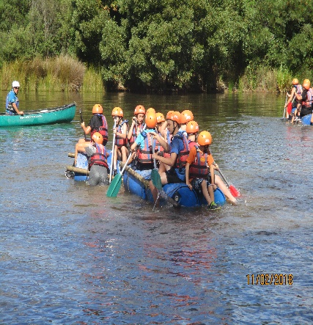Many significant excursions also take place from Years 7 to 10 and complement curriculum content or offer experiences not possible in a classroom setting.

Leadership development is encouraged through this program.

Payment for camps can be made in full or by instalment and EFTPOS is available at the Finance Office of the College.

# Careers & Pathways:

ESC offers a Pathways service to all of its students. This involves career advice, assistance with subject and course selections, resume writing, obtaining part time or casual employment and a wide variety of vocational programs.

The Pathways area in Senior Grieve has a range of resources available to students including information about apprenticeships, traineeships and tertiary institutions.

For year 10 students, some Teacher Advisory time is allocated to preparing for work experience, exploring post year 10 options and preparing individualised Managed Individual Pathways Plans.

# Music - Bendigo Instrumental Music Program (BIMP)

Musical instruments are offered for tuition at reasonable costing for families. We offer the following instruments for tuition- flute, clarinet, saxophone, oboe and bassoon. Trumpet trombone, French horn and tuba. Violin, viola and cello, Guitar- all styles, electric, bass and acoustic and drums.

Opportunities for Student Voice and Leadership

The College provides a range of Leadership Opportunities for junior and senior students. These include Student Representative Council, Junior and Senior Neighbourhood Leaders, Junior and Senior Sport Leaders and School Council Student Membership. There are also mentoring opportunities for students and a Student Executive Leadership Team who elect two School Captains. This provides a genuine voice for students in the school as well as expanding their opportunities for leadership development.

Reporting to Parents

Parents obtain regular feedback about student progress and competencies through:

* Fresh Start Parent / Teacher / Student interviews at the start of each year
* 5-6 week progressive assessment and reporting process which is available to parents on COMPASS
* Comprehensive end of semester reports on Vic Curriculum
* General progress, support and wellbeing at school
* Home phone & email contact by teachers
* Subject based Parent/Teacher Interviews during the year

# Student Support Services

Eaglehawk Secondary College has developed a comprehensive range of services designed to promote the well-being of all students.  Each service has its own special brief, however, it is important that students and parents understand that all services are available to all students.

* Student Wellbeing
* College Chaplain
* Student Services
* School Engagement Worker
* Student Attendance Support Worker
* Koori Education Support Officer
* School Nurse
* DET Regional Support Workers
* Eaglehawk Secondary College - Connect Program

# Inclusion

If your child has a diagnosed disability and receives funding support at Primary School or has been assessed by a Speech Pathologist please contact the Inclusion Co-ordinator for more information about the support we can offer your child when he/she starts at the College. Any support information that you can provide to the College on enrolment is very helpful to this process.

Students with literacy and numeracy difficulties will be supported by their classroom teacher and tutoring assistance will be provided if required.

Assessment and Reporting - COMPASS

Your child will receive progressive assessment of their learning throughout the year in each of their subject areas. Learning Tasks will be available on COMPASS for you to view your child’s assessment throughout units of work taught. At the end of each semester you will receive a report containing particular Learning Tasks from each subject area across the semester. Achievement will be reflected using an A to E scale as well as feedback in the form of comments. Student performance will be assessed against Victorian Curriculum Achievement Standards as part of the semester report and will be indicated by progression point. At the end of the semester the complete report will be printed at school and sent to you.

COMPASS Learning Platform

Eaglehawk Secondary College uses a computer program called COMPASS to manage student information and communicate and gain with parents and students. COMPASS is a learning platform that allows students, teachers and parents to access a range of school and student information. It’s important that parents and carers feel connected to their child’s learning and development while at school. COMPASS allows for quick and easy communication and feedback between parents, teachers and students and can be accessed from anywhere online on any device.

Through COMPASS you will have access to:

• Easy communication with your child’s Teacher Advisors and classroom teachers

• Your child’s attendance

• Current and past reports

• Learning tasks set for your child by their teachers and curriculum information

• NAPLAN and other benchmark assessment data used by the College

• Notices about activities at school.

• School calendar

**Project Based Learning (PBL)**

Each Year 7 student will participate in a subject titled PBL. Project Based Learning gives students the opportunity to apply the skills and knowledge they learn in school to personally relevant and real-world situations. The subject areas of Science, Humanities and Literacy through student driven projects supported by explicit teaching of content skills and knowledge and applied learning. Students will have the opportunity to further specialise into areas of interest in Year 9/10 through the elective program. Some of these Science subjects include: VCE psychology, STEAM, Gadgets and Gizmos, Biology, Physics, Human Mind, Chemistry, Sports Science, Health and Medical Sciences in the Science field. Subjects within Humanities may include Shark Tank, Pop Culture, Law and Order, VCE Legal Studies and many more.

**Curriculum**

# The Year 7 Curriculum aims to build on the good teaching undertaken by teachers in primary school. Students continue to have Literacy and Numeracy as a key focus and are introduced to a broad range of specialist subjects. Developing basic skills and safe work practices are the main focus at Years 7 and 8.

# The timetable is structured with 4 periods per day, 20 per week.

|  |  |
| --- | --- |
| **SUBJECT** | **YEAR 7 & 8** |
| English | 4 periods |
| Maths | 4 periods |
| Inquiry - Science | 2 periods |
| Inquiry- Humanities | 2 periods |
| Visual Arts  Performing Arts  *Instrumental Music  *Marrung Dance Academy | 2 periods |
| French (Year 7 only) | 2 periods (1 semester) only |
| Indonesian (Year 7 only) | 2 periods (1 semester) only |
| Indonesian (Year 8 only) | 2 periods (1 semester) only |
| French (Year 8 only) | 2 periods (1 semester) only |
| PHASE PE, Health Sport | 2 periods |
| Technology  Hard Tech, Foods, Fabrics | 2 periods |

*The Marrung Dance program is for female indigenous students attending the College whilst the Instrumental Music program is a co-curricular program available to any student in the College

**Year 9 & 10**

As students they are provided with more opportunity to specialise in different subjects. The following grid shows the curriculum on offer for 2020. All students in Years 9 and 10 undertake 4 periods of Maths and English. All electives are either two or three periods.

|  |  |  |  |
| --- | --- | --- | --- |
| **SUBJECT** |  | **Year 9** | **Year 10** |
| English | 4 periods | EnglishAdvanced EnglishCollege MagazinePublic Speaking & Debating | EnglishAdvanced EnglishCollege MagazinePublic Speaking & Debating |
| Maths | 4 periods | General MathematicsNumeracy (introductory)Advanced Mathematics | General MathematicsAdvanced MathematicsNumeracy |
| Science | 2 periods | Core Science –understanding our worldSports ScienceGadgets & GizmosThe Human MindSTEAMHealth & Medical Sciences | Core Science – biology/geneticsCore Science – chemical worldCore Science –Physical WorldHealth & Medical ServicesThe Human MindGadgets & GixmosSports ScienceAnimal studies – DomesticAnimal studies – AgricultureBologyVCE PsychologySTEAM |
| Humanities | 2 periods | Australians in ConflictPop CultureRights & FreedomWar on WasteShark TankAround the WorldCross Age TutoringLaw and Order | Australians in ConflictPop CultureRights and FreedomWar on WasteShark TankAround the WorldCross Age TutoringLaw and orderVCE Legal Studies (1 & 2) |
| LOTE | 2 periods | French or Indonesian | French or Indonesian |
| Art | 2 periods | Sculpture – 3D artVisual & Graphic communicationArt GeneralPhotographyPotteryMusic Theory & AppreciationCreative AnimationDanceProduction | Sculpture – 3D artVisual & Graphic communicationArt GeneralPhotographyPotteryMusic Theory & AppreciationCreative AnimationDanceProduction |
| Health & Physical Education | 2 periods | Outdoors & Rec ActivitiesSports for LifePhysical Education – GirlsPhysical EducationEnergy BreakthroughSports Development ProgramAdvanced Physical Education | Outdoor EducationHealth & First AidPhysical Education – Girls\Physical EducationEnergy BreakthroughVCE Physical EducationSports Leadership & CoachingSports Development Program |
| TechnologyHARDSOFT | 2 periods | WoodworkGrand DesignsSmall engines & SystemsWelding/EngineeringCreative Metals/jewelleryElectronicsRoboticsApps developmentICTFabricsDesigning for FashionFood From ScratchPlan, Harvest & Eat | ElectronicsSmall Engines & SystemsRoboticsApps DevelopmentWoodworkCreative Metals/jewelleryWelding/EngineeringICTGrand DesignsPre Driver EducationVET EngineeringBuilding Buddies – building beyond the classroomFabricsDesigning for FashionVET HospitalityWorld of FoodsFood From ScratchPlan, Harvest & Eat |
|  |  |  |  |

# **The School Day**

One of the good things about Eaglehawk Secondary College is that with the new school building most of your classes will be in a particular part of the College not unlike what Primary school is like.

An important part of your day will be your Teacher Advisory Time which starts at the beginning of the school day. Here the roll will be marked and then time will be allocated to discussing issues with your Teacher Advisor (T/A), doing circle time or activities so that you can get to know your T/A and fellow class mates better and develop skills that will assist you at school and at home.

**BELL TIMES**

|  |  |  |
| --- | --- | --- |
| Period | Time | Length of session |
| Advisory | 9.00 | 20 min |
| 1 | 9.20 | 70 min |
| Recess | 10.30 | 25 min |
| 2 | 10.55 | 70 min |
| 3 | 12.05 | 70 min |
| Lunch | 1.15 | 40 min |
| 4 | 1.55 | 70 min |
| Finish | 3.05 |  |

# **ATTENDANCE**

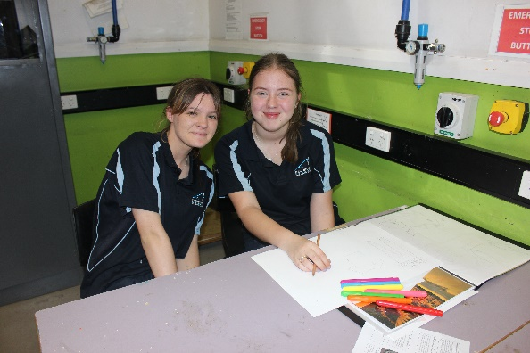**ATTENDANCE AT SCHOOL *–*** is closely monitored with attendance uploaded directly to the College’s learning platform. This can be assessed by parents at any time. Students should aim to attend 95% or more and parents are encouraged to contact the College when they have concerns.

# **ATTENDANCE HOTLINE NUMBER**

# **ph. 4433 8282**

Parents are asked to ring this number to report a student’s absence from the College.

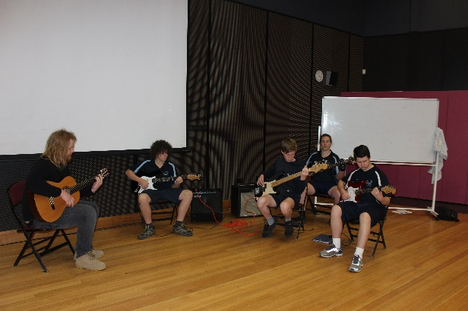

# **ESC Uniform Policy**

Eaglehawk Secondary College Council has a policy that all students will wear uniform. In doing so the College believes that students will be given an identity and a sense of belonging. Uniform is an important element in promoting the College’s image in the wider community. A uniform ensures that a common standard is applied to all. The College uniform is designed to be easy for students to wear and affordable to parents. All items will be available with the College logo.

The Uniform

**Winter**

* Plain Navy Blue pants, (cargo or tracksuit style accepted; **no Jeans/denims;** no labels, logos, stripes, leggings)
* Two tone Navy & Light Blue Polo Shirt – long sleeve option available
* Navy Blue Windcheater / Polar Fleece or College Hoodie
* College Rugby Top
* Winter Skirt (for girls)
* College spray jacket

**Summer**

* Navy Blue Shorts; (no labels/logo/stripes; ¾ pants **not accepted.)**
* Two tone Navy & Light Blue Polo Shirt – long sleeve option available
* Summer Dress ( for girls)
* Bucket Hat (encouraged)

Summer and Winter options apply to both boys and girls.

**Shoes**

Students must wear safe enclosed shoes that are compliant with health and safety at the college.

*Opened toe shoes and shoes such as Ballet Flats are not acceptable footwear at the College*

This uniform offers an affordable and practical choice for parents, is comfortable and reflects student preference. It reinforces local identity through its choice of colours and the provision of a school logo. The concept of uniform is overwhelmingly supported by the students, parents, and staff of Eaglehawk Secondary College.



The uniform policy is a condition of enrolment and forms part of an agreement between parents, students and the College. Parents agree to endeavour to send their students to the College in uniform, students to wear uniform at all times and the College to reinforce

**CENTAVIC CLOTHING**

Factory 2/1 Whip Court, Long Gully

Phone/Fax: 03 5441 7555

Trading Hours: Mon-Fri: 8.00am - 5.00pm

[sales@centavicclothing.com.au](mailto:sales@centavicclothing.com.au)

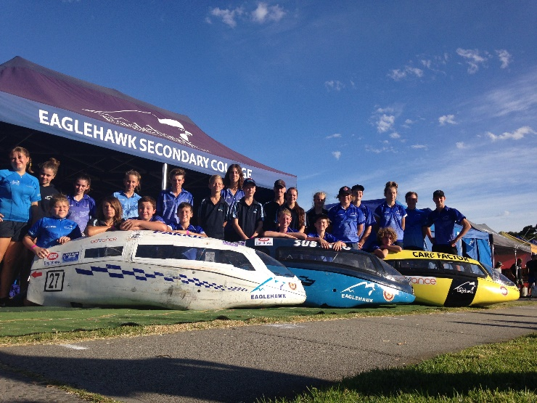

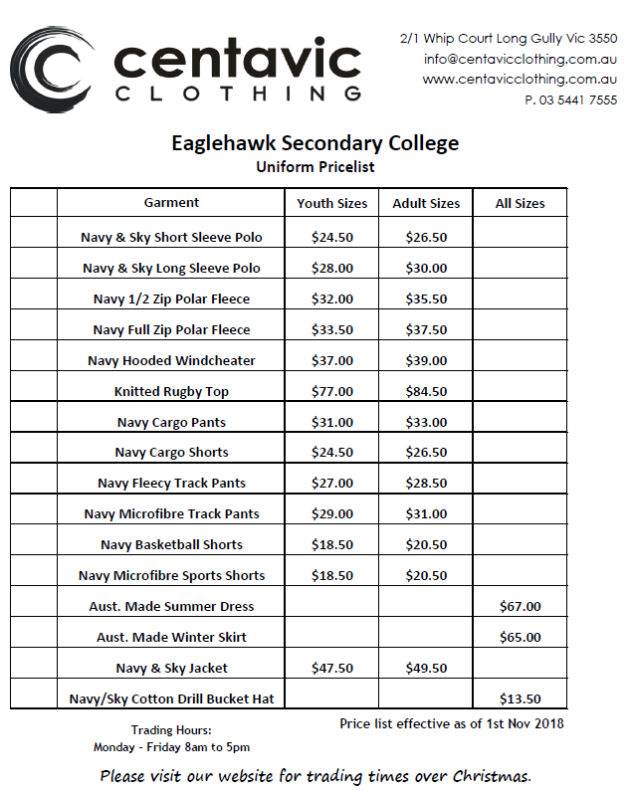

# **Core Behaviours**

# Core behaviours are expectations of students in the College. They have been developed by our students for our students.

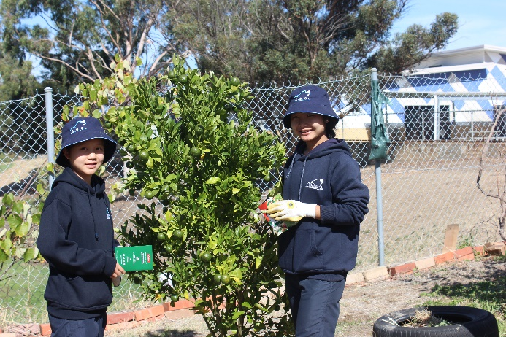**Community**

I participate actively

I treat all members of my community with respect

I support and encourage my community

I treat our community facilities with respect

**Opportunities**

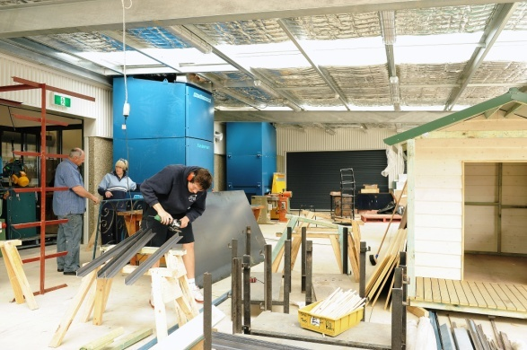I accept challenges

I try new things

I seek opportunities

I go outside of my comfort zone

**Relationships**

I treat people with respect

I accept individuality

I am honest and trustworthy

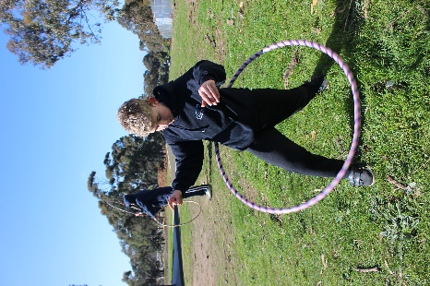I co-operate with others

**Expectations and Achievements**

I always do my best

I work hard to achieve my goals

I am organised

I persist when things get tough

# **Things to know about the school**

**Teacher Advisory Group**

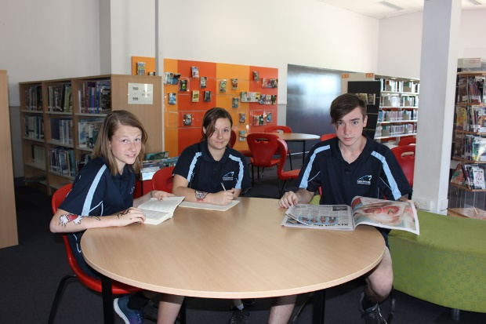You will be placed in a Teacher Advisory group or T/A group. This group will consist of students starting Year 7 and efforts will be made so that you will have some friends from Primary school in your T/A group. In Year 7 most of your classes will be taken with this group. You will also belong to one of four Neighbourhoods – Walker, Grieve, Lester and Dowding. You will remain in your Neighbourhood for the remainder of your stay at Eaglehawk Secondary College.

**Leaving the grounds**

If you wish to leave the grounds for any reason you MUST have a note from a parent or guardian asking permission to leave and the required times. This note must be given to your T/A at the beginning of the day, and should give the reason that you need to leave. You must sign in and out at the General Office when you leave, and also when you return.

**Possessions**

There are certain possessions that must not be brought to class such as bags. Mobile phones should be turned off and out of sight while you are in class unless under the direction of the teacher. Any lost or found items are to be taken to the College General Office. You can also report the loss of any property to the College office. Money for excursions or fees can be paid to your T/A or College office staff. REMEMBER that whilst you expect people to respect your property, we at Eaglehawk Secondary College expect you to respect the property of the school and of others.

**Mobile phones**

These are now a part of everyday life. It is important that they are used appropriately. Phones may be used in class under the direction of the teacher. Otherwise they are away and not for use. It is illegal to send threatening messages, recorded images without permission or to access offensive material. The College will act promptly where mobile phones are used inappropriately. The school will take no responsibility for the loss of a mobile phone.

**Netbooks**

All students at Eaglehawk Secondary College will have their own Netbook that is provided by the College and supported by parents. Every student will have their own secure locker where Netbooks can be stored safely at recess and lunchtime. Students take their Netbooks home every day to use at home and to recharge it.

**Homework Policy**

Students will be receiving homework and it is expected that this homework be completed. Students are encouraged to complete work started in class. It’s a good idea to get into the habit of doing at least one hour of homework per night so that when work is due you will not need to panic.

**Bus Travel**

Where numbers are sufficient the Government provides a free bus service on certain routes for students that live further than 4.8 km from their nearest Secondary School. To find out if your child can access this service please visit the School Bus Management System (SBMS) online at **schoolbusapplication.ptv.vic.gov.au** for a Pre-Application Check. Country bus students are supervised after school and provided with afternoon tea. An approved country bus application must be completed before your child travels on the country bus. Further information is available from the school office or by telephoning PTV on 1800 800 007.

Public Transport is also available to all students. Wherever you want to go in and around Bendigo public transport buses can take you. Student passes and student concession cards are available. A Myki card needs to be purchased from Newsagencies or V/Line.

**Practical Fees**

In many of the subjects studied next year, students use materials such as text books, food, clay, wood, paint etc. to aid learning or make products, which they eat or keep. The total fee for these subject materials are listed on the Colleges book list which is distributed to students later in the year. The College works closely with its community to keep these costs to a minimum.

# **What should I do if?**

**I get lost?**

Ask for help by calling into the General Office or make contact with your T/A.

**I lose my timetable?**

You can get a spare copy of your timetable at the office or ask your T/A. The main thing to remember is DON’T PANIC!!!

**I’m being picked on?**

Tell someone. Tell your Teacher Advisor (T/A) or a teacher/adult you trust at the school. Nobody can help you if they don’t know what’s going on.

**I want to order my lunch?**

If you want to order one of the special items such as nachos, pizza or wedges, you can order these in your Learning Community or at the canteen at recess. You are given a ticket, which you hand in at lunchtime. You can buy other lunch items at lunchtime.

**I want to go home at lunch?**

See the College Office for a lunch pass form. Lunch passes are only issued on receipt of this form signed by your parents which indicates that you are going home for lunch and that an adult will be present. This lunch pass is valid for the year. Note that a lunch pass cannot be used to go down the street for lunch.

**I am late for class?**

Being late for school is unacceptable. If you are late for class and do not have a note from a teacher or parent then your teacher will have specific rules relating to this. It may mean you are given extra work or that you are given a detention. It is important to be on time for all classes.

**I don’t have correct uniform?**

Students should not be out of uniform. If due to exceptional circumstances a student is out of uniform they should have a note from a parent, which they should show their T/A during T/A time. If a student is repeatedly out of uniform then a parent will be contacted to ask why, and on occasion a student will be ask to change into a uniform provided by a Neighbourhood Leader. The College can support parents and students with the provision of uniform items where this creates financial difficulty.

**I am feeling sick in class?**

Sit quietly. If the illness continues ask for permission to go to the General Office to attend the sickbay. If necessary your parents will be contacted. Under no circumstances should a student leave the College to go home without reporting to the office first.

**I need a locker or a lock?**

On starting Year 7 a student will be allocated a locker and a lock. Both are the responsibility of the students for the rest of their time at College. Note lockers have room for a school bag and helmet. No writing or pictures are to be pasted or stuck to the locker and any damage to a locker will be paid for by the student. Timetables can be blue tacked to the inside of a student’s locker.

**I want to learn a musical instrument?**

See Mrs Chalmers who will help you make arrangements with the Instrumental Music Teachers.

**I ride my bike to school?**

Store your bike in the racks in the bike shed, which is kept locked during the day. Make sure that you have a lock and chain to secure you bike. The school cannot accept responsibility for bikes stored. It is the responsibility of the owner to report the theft of a bicycle to the police. Students must wear helmets while riding their bicycles to and from school.

**I can’t do sport?**

Bring a note explaining why you cannot do sport and give it to your PE teacher. You will remain in that class under the supervision of your teacher.

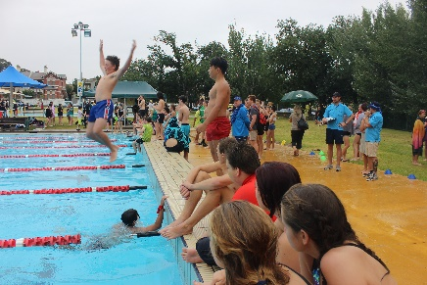**I can’t afford something I need for school?**

Speak to your Teacher Advisor first; we try to help whenever we can. Students should not miss out on things because of financial difficulties, and these matters are kept strictly private.

**I can’t get along with a teacher?**

Ask someone you trust for advice. Your Teacher Advisor or Neighbourhood Leader should be the first option otherwise you may seek assistance from the Student Support Services.

**I want to leave the school before the end of the day?**

You will need to have a note from home (parent or guardian) show your T/A and handed it in at the office. Don’t forget you will need to sign out at the General Office.

**I’m away from school?**

When you return to school bring a note to explain your absence. Give the note to your Teacher Advisor. The note should have your name, the date of your absence, the reason for your absence and it should be signed by the adult who takes care of you.

**I’m late to school and T/A time?**

Report to the General Office and receive a late note before going off to class (NB it is necessary whenever you are late to class to obtain a late note—this is simple courtesy). The roll will be adjusted. If this lateness becomes a habit then your T/A will contact a parent to discuss the reasons behind this.

**(All students require a note from parents when they are late.)**

**I’ve got problems outside school?**

If things are troubling you and are affecting your schoolwork, seek out help from someone you trust. Your T/A is a good person to start with. We may not be able to change anything, but sometimes it helps just having someone who knows the situation. We will try to put you in touch with people who can help, or work with you to solve the problem.

**E-learning program**

In a 1-to-1 learning program, each learner has a portable, networked device (netbook) that can connect each learner with their teacher and other learners or experts, with real-world contexts for learning, multimedia resources, software for learning and online tools and applications. An E-Learning Agreement is included for every new enrolled student to complete.

# **What you can expect from your teachers**

Your teachers are committed to making your time at school one where you experience success and reach your potential. To achieve this, the College staff will:

* 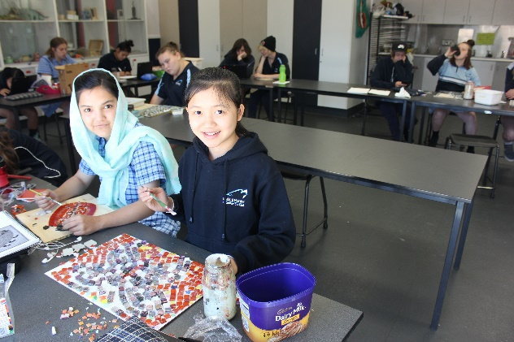Provide caring, respectful and positive support
* Be inclusive of individual needs
* Recognise significant achievements
* Maintain communication with home regarding attendance issues
* Encourage all work to be completed
* Be available to be a mentor and advocate
* Encourage extra-curricular community involvement
* Consistently follow through on all College processes to support learning

# **What we expect from students**

It is proven that if you actively follow through on what is listed below, then as a student you are well on the way to achieving the best results you can at school, feeling great about yourself and on the way to getting the job you want in the future.

* Attend school everyday
* Be on time to class with all required equipment
* Be an active participant in Teacher Advisory time in the morning.
* Complete all provided work for assessment, including work missed due to absence
* Follow the school rules
* Accept responsibility for your choices and where you need to restore your reputation, complete given consequences
* Be a positive ambassador for your college in the community

# **What parents can do**

The College encourages parents to be actively involved in their child’s time at Eaglehawk Secondary College. Some things you can do to ensure that your child has a successful and enjoyable year include:

* Send your child to school every day. All students should aim for a 100% attendance
* Ensure that your child is in full school uniform with the required books and materials
* Make sure work is being completed, check using the College’s learning platform COMPASS, provide a study location at home and develop homework habits
* Contact your child’s Teacher Advisor to discuss any concerns
* Attend Parent/Teacher meetings
* Ring or email the College before 9.30am for any short term absence
* Support the College camp program by your child attending the camp or regular school
* Where possible, attending extra-curricular programs your child is involved in, eg. sports, music, arts
* Actively promote the College in the community

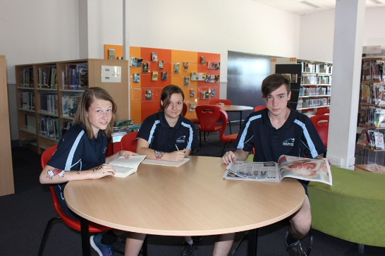

**Eaglehawk Secondary College**

***Social Media Code of Conduct***

**The Code of Conduct**

Social media is a way of interacting with family and friends through the use of technology. Social media sites allow students to plan events with others and also connect through the internet.  Students are able to see what family and friends have been doing via status updates or tweets.

Social media also allows people to target others while hiding behind a screen; many comments said online are not expressed in ways one would use when speaking face to face, and can often be misinterpreted.

**The purpose of the Eaglehawk Social Media Code of Conduct is to provide students, as members of the Eaglehawk Secondary College Community, a guide to responsibly use Social Media.**

**At Eaglehawk Secondary College, we value:**

* our friends, family, classmates and our community
* honesty, trust, and following school rules online and offline
* the privacy of others
* ourselves
* leadership, cooperation and trust
* striving to act in a respectful manner

**Every Eaglehawk Secondary College student has the right to:**

* Share their opinion, keeping in mind that online posts can stay online forever
* Feel safe online and not be abused or picked on
* Keep their personal lives separate
* Be supported or support other students
* Stay safe online and not have to deal with negative and/or offensive comments or retaliations
* Tell an adult if someone is bullying them online
* Make their own decisions and don’t give in to peer pressure

**Eaglehawk Secondary College students see appropriate use of social media to include:**

* Accepting individual opinions and choices
* Treating other students equally, fairly and respectfully online and offline
* Recognising that online actions have consequences, both online and offline
* Supporting our friends to be responsible
* Following online rules
* Presenting ourselves and Eaglehawk Secondary College in a positive way
* Respecting others at anytime

**Eaglehawk Secondary College Students have the responsibility to:**

* Take responsibility for what they post online and represent Eaglehawk Secondary College positively
* Avoid retaliating to negative comments made online – don’t “bite back”
* Own up and apologise for and take responsibility if one has done something wrong
* Avoid becoming involved in anything illegal or inappropriate online that may affect personal lives
* Promote positive social media use when using sites such as Twitter, Facebook, MySpace etc….
* Don’t say anything that will make other people think less of an Eaglehawk Secondary College Student
* Adjust privacy settings and don’t share personal information or that of a schoolmate online
* Show consideration towards other people’s feelings when posting online
* Stay loyal to schoolmates and Eaglehawk Secondary College when communicating online





**EAGLEHAWK SECONDARY COLLEGE MAP**

Inclusive Learning Centre

Technology

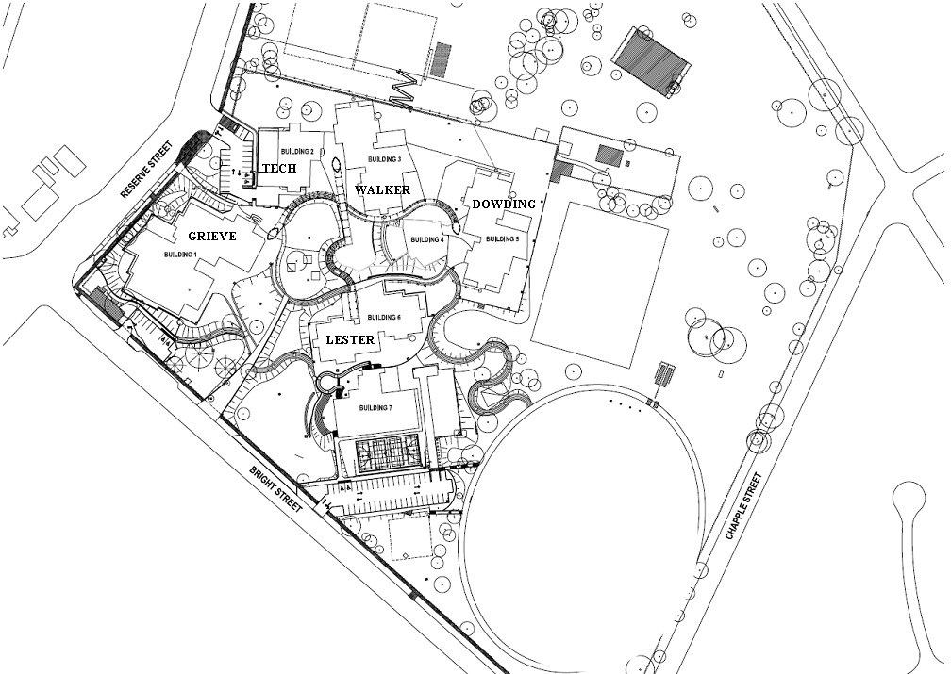

Library

Gym

Performing Arts – Black Box Theatre

Admin