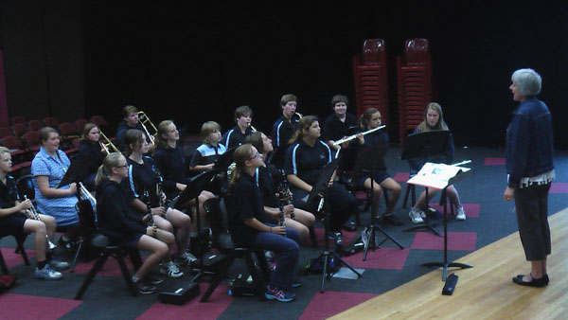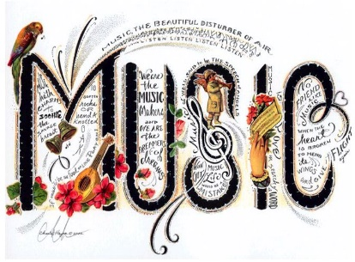

**Instruments**

Students can choose from the Flute, Saxophone, Clarinet, Oboe, Trumpet, Trombone, French horn, Tuba, Violin, Viola, Cello, Drums, Bass, Acoustic and Electric Guitar.

**Finance Solutions**

At Eaglehawk Secondary we understand the financial strain that the beginning of the year holds for our families.

If finance will be a problem, the school is happy to work out a payment plan, but ask for a deposit to secure the students place in the program.

*“I never wanted to be a famous musician, just a good one.”*

* Ray Charles

*“Music and rhythm find their way into the secret places of the soul.” -* Plato

**Cost**

Base fee of $180 for the year regardless of instrument chosen for study- Bendigo Instrumental Music Program and Bendigo Schools Symphonic Band Fee

Hire of instruments is available at a small cost. $100. This goes towards maintenance of Eaglehawk Secondary College instruments so we can guarantee that your child is learning on an instrument of good quality.

**What we expect of students**

Practise as often as possible. The more regular practise they can manage the better musician they will be.

Remember to speak to the class teacher of the class they are missing before attending the lesson.

Notify the instrumental teacher if they are unable to attend the lesson.

**General Information**

Music lessons are once a week for half an hour. Students are withdrawn from class and lessons are held on a rotating timetable so a different class is missed each week. Most lessons are group lessons at year 7 level and are held in the Wes Vine Performing Arts Centre.

*“Music is the literature of the heart: it commences where speech ends.”*