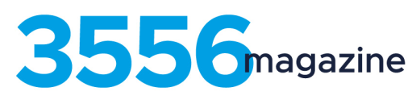

3556Magazine is produced by ESC students four times a year to promote all the positive things going on within the 3556 community. Editions are produced in autumn, winter, spring and summer.
HOW IT WORKS:
Any student can be involved.

Working with Danielle Duval and Michael Watson, students follow their interests to create stories/pages/art work etc. that is then published in the magazine.

If you love taking photos, writing reviews, drawing comic strips, designing ads, interviewing people, writing stories – the list goes on and on – come and join us!

The magazine is distributed to approx. 3000 people in and around Eaglehawk and also has a website which is updated regularly and offers extra chances to be published.

Students participating in 2020 will attend sessions once per week at various times to ensure the same classes are not missed. Credit towards English work can also be organised on an individual basis. Keep an eye on Compass for more details.

There will be an initial meeting at the beginning of 2020 after which interested students will be coached in interview technique, photography and writing prior to going out into the 3556 region to meet with and interview community members. Students will then receive guidance to plan and publish their report.

To express your interest in participating in the 3556Magazine Team, please complete the information below and return to the General Office.

Name:……………………………………………………………………………………………..

Year level:………

